MongoDB Operations Assignment
Database and Library System

This report demonstrates database setup, insert, read, update, query-operator, and delete operations in MongoDB. Each command is followed by its corresponding mongosh screenshot.

Student Database
- Database & Collection Setup:
1.Create a new database
Command
use StudentDB
2.Create a collection
The student collection is created automatically when the first db.student.insertOne() command is executed.

2. Insert Operations
1. Insert One Document
Command
db.student.insertOne({name:"Anu",age:21,course:"ECE",status:"Active"})

2.Insert Multiple Documents
Command
db.student.insertMany([
{name:"Arun",age:21,course:"EEE",status:"Active"},
{name:"Abi",age:20,course:"IT",status:"Active"},
{name:"Akash",age:24,course:"CSE",status:"Graduated"},
{name:"sara",age:23,course:"IT",status:"Graduated"}
])
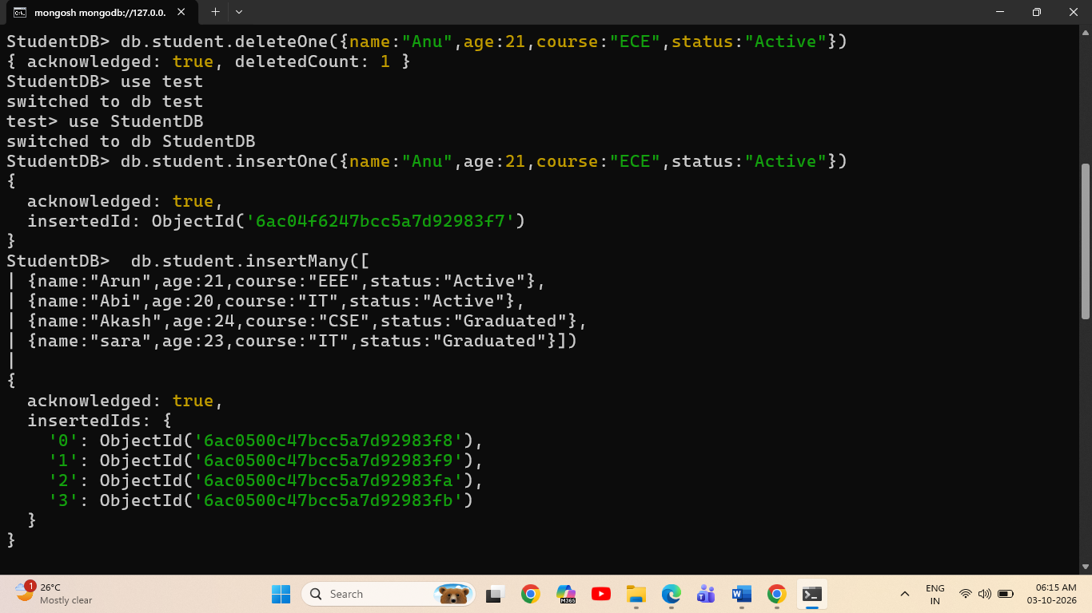

3. Read Operations
1.Fetch All Documents
Command
db.student.find()

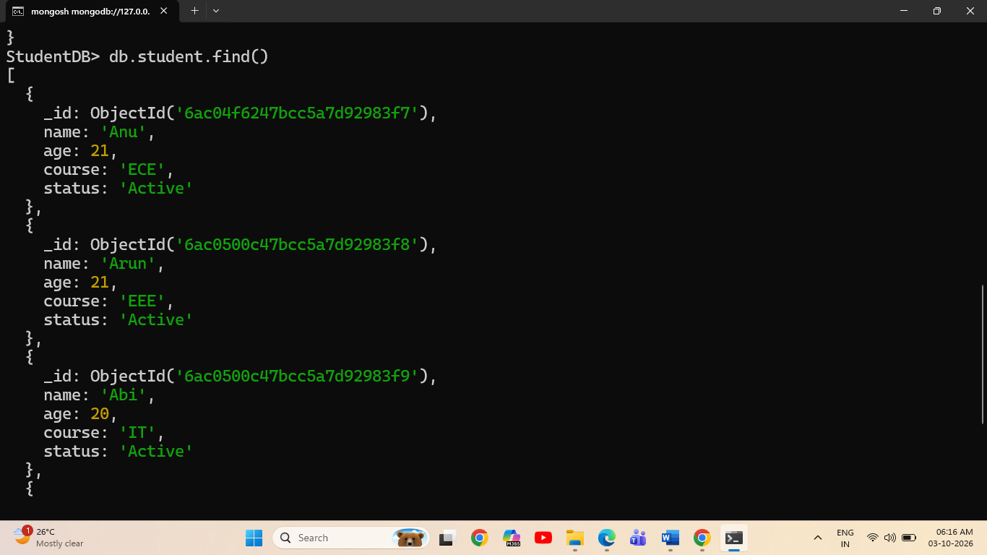

2.Filter Students by Age
Command
db.student.find({age:21})
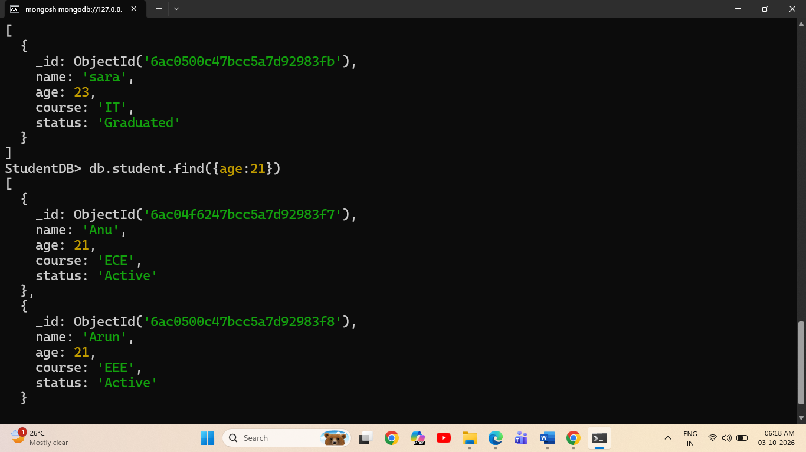

3.Project and Exclude Fields
Command(included)
db.student.find({age:21},{name:1,age:1})
Exclusion command
db.student.find({},{status:0})
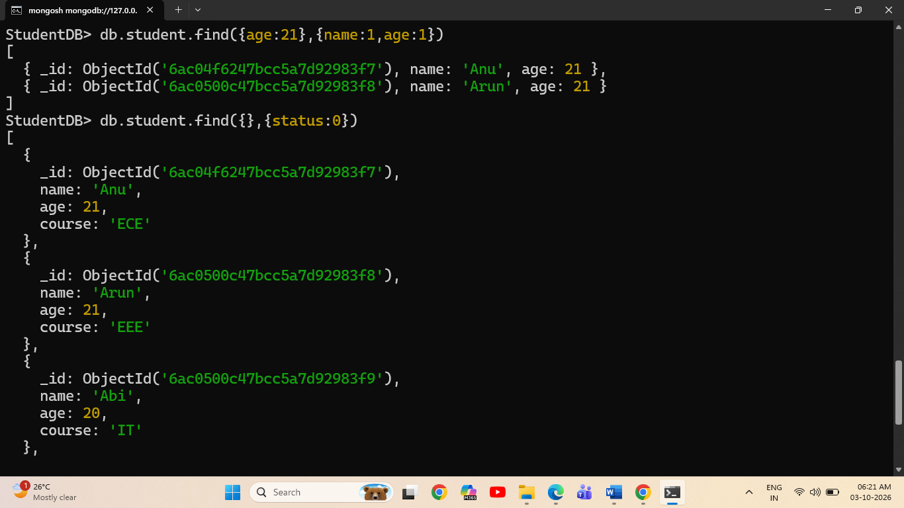

4. Update Operations
1. Update One Document
Command
db.student.updateOne({status:"Active"},{$set:{status:"Graduated"}})

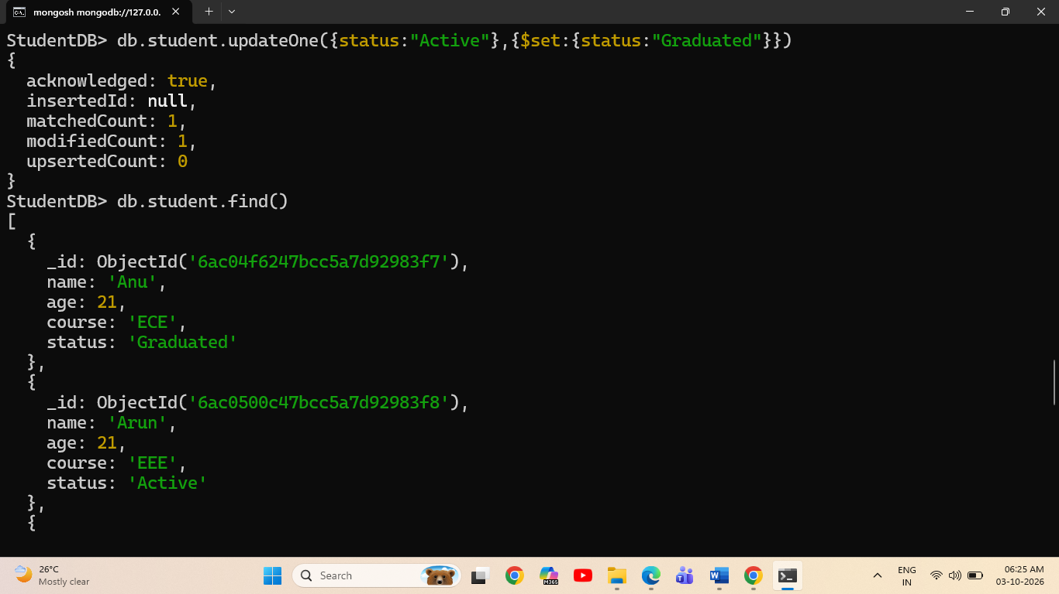

2. Update Multiple Documents
Command
db.student.updateMany({age:21},{$set:{status:"Graduated"}})

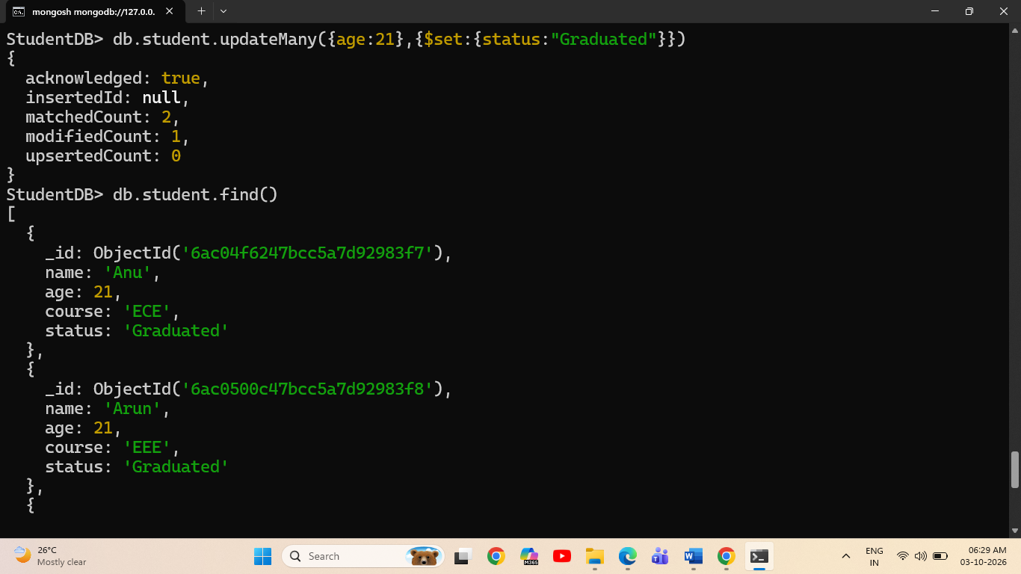

5 Query Operators
Greater Than and Greater Than or Equal To
$gt command
db.student.find({age:{$gt:21}})
$gte command
db.student.find({age:{$gte:21}})

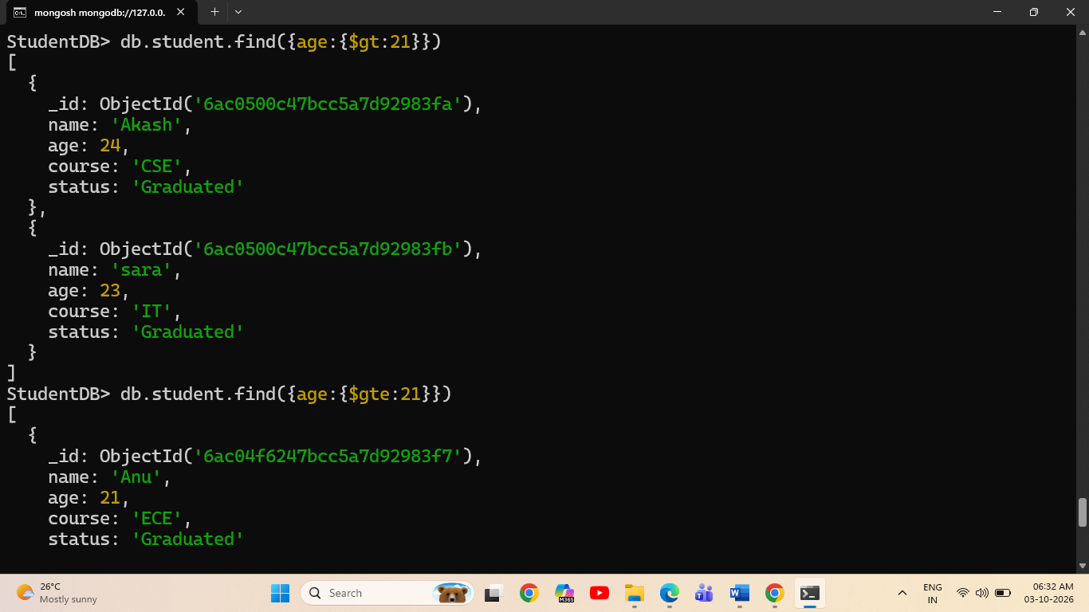

Less Than and Less Than or Equal To
$lt command
db.student.find({age:{$lt:23}})
$lte command
db.student.find({age:{$lte:23}})
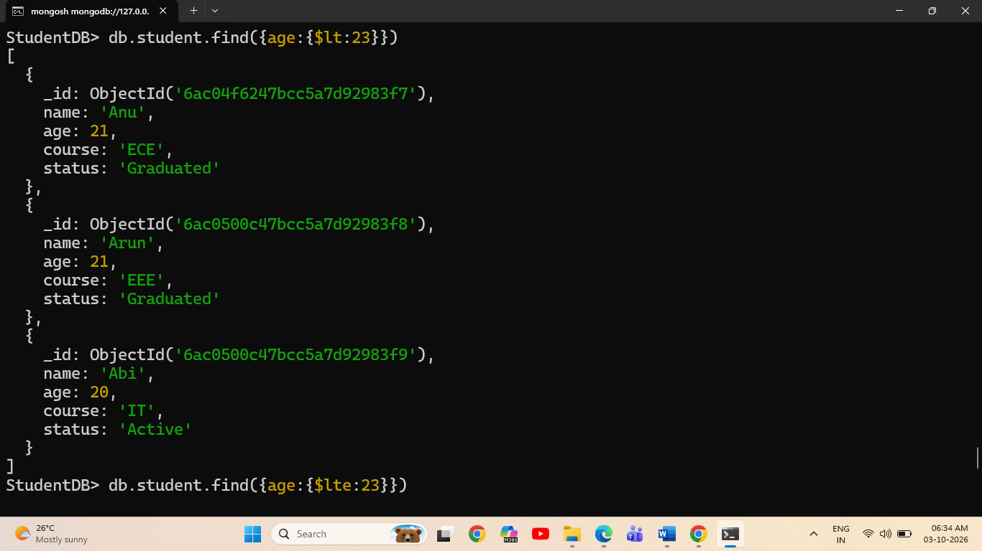

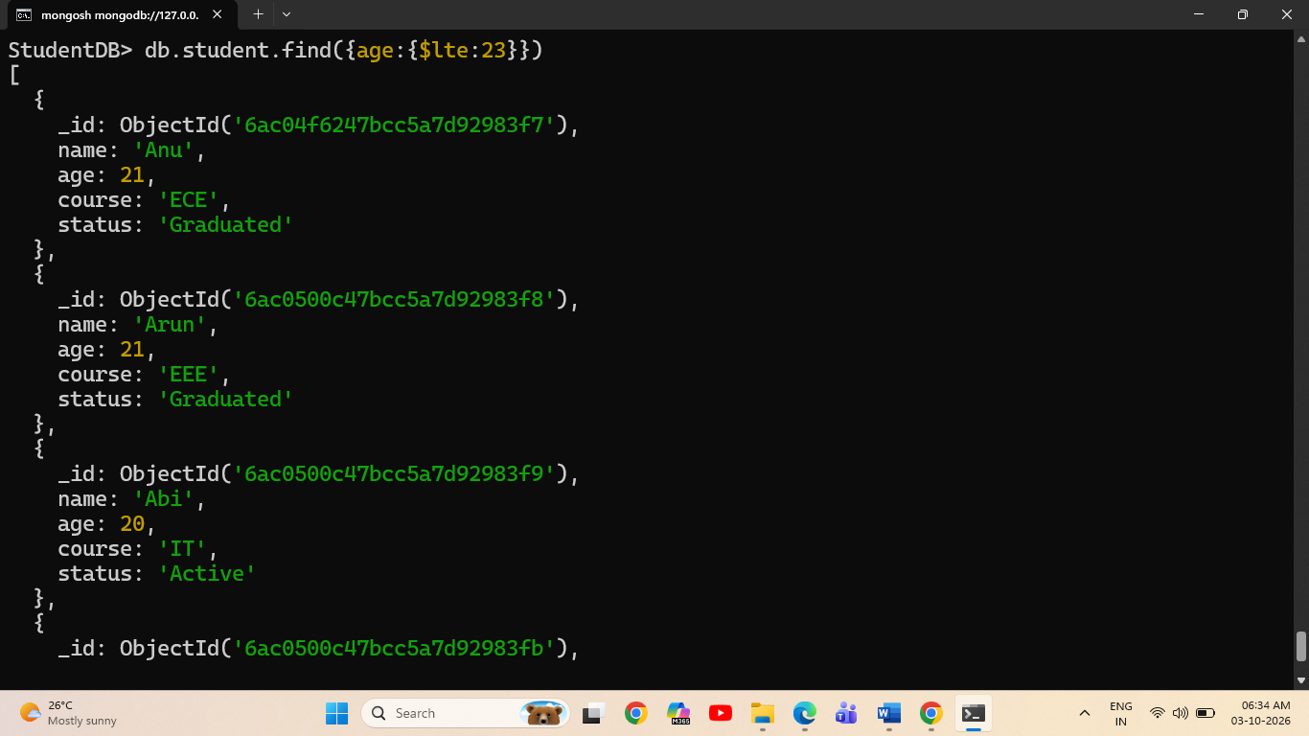

In Operator
Command
db.student.find({course:{$in:["CSE","ECE"]}})
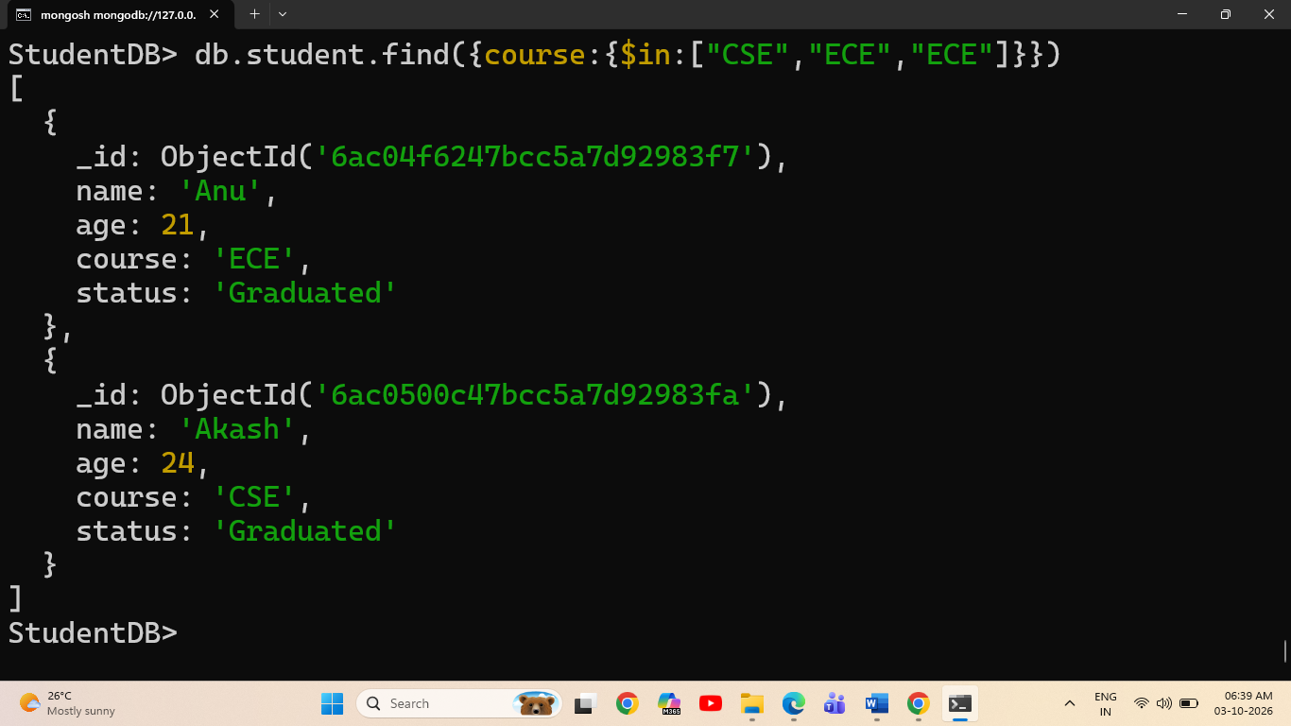
AND and OR Operators
$and command
db.student.find({$and:[{status:"Graduated"},{age:23}]})
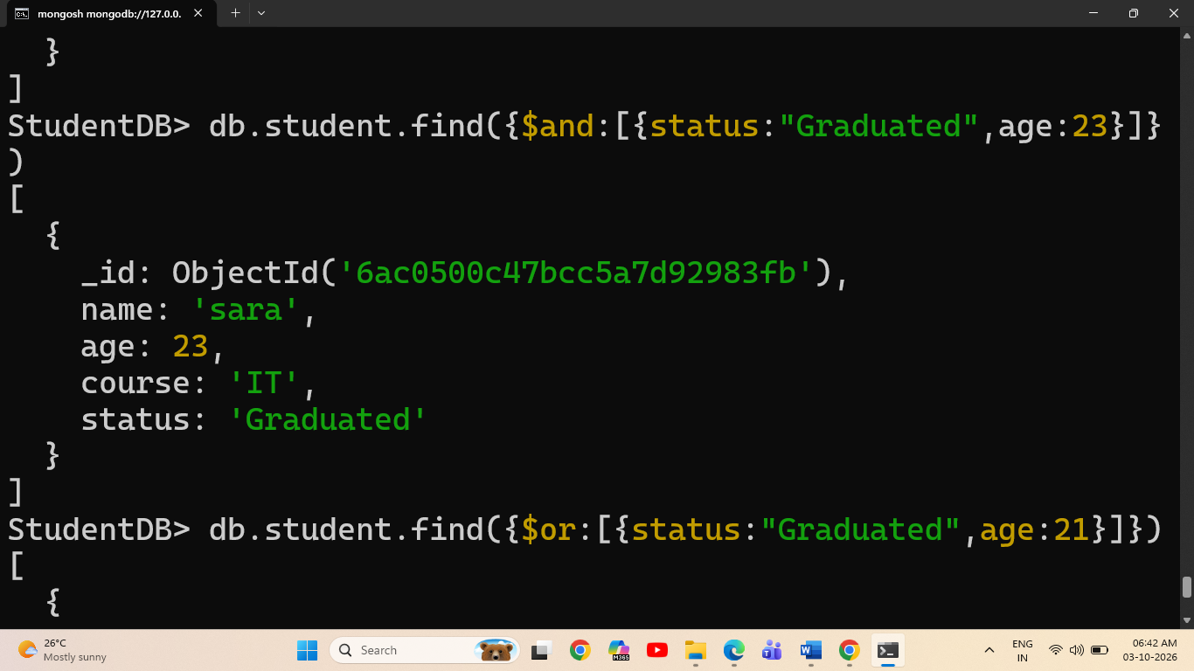

$or command
db.student.find({$or:[{status:"Graduated"},{age:21}]})
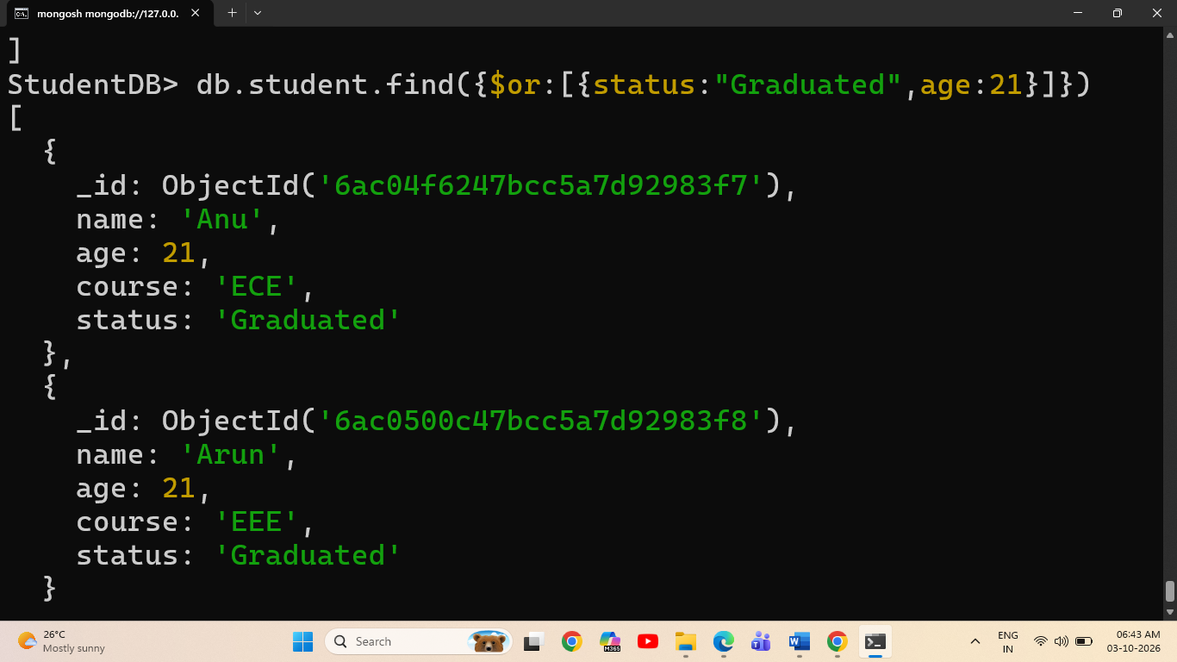

Exists Operator
Command
db.student.find({name:{$exists:true}})
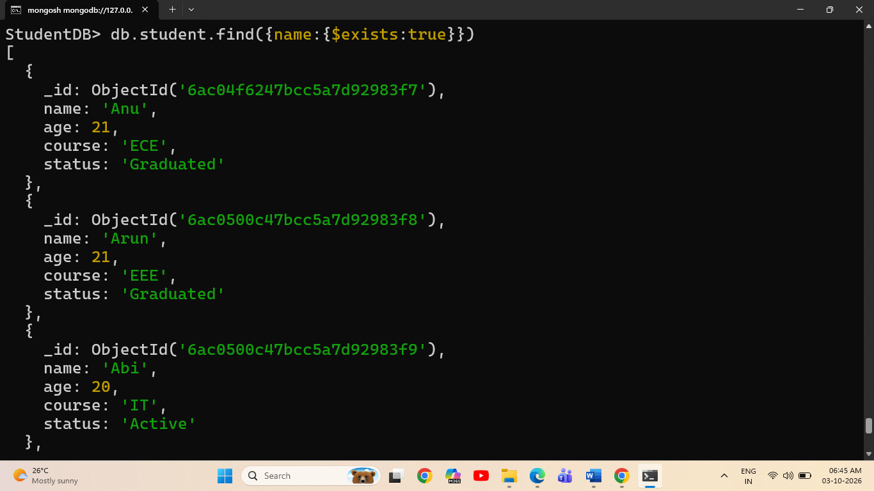

6. Delete Operations
Delete One Document
Command
db.student.deleteOne({name:"Anu"})

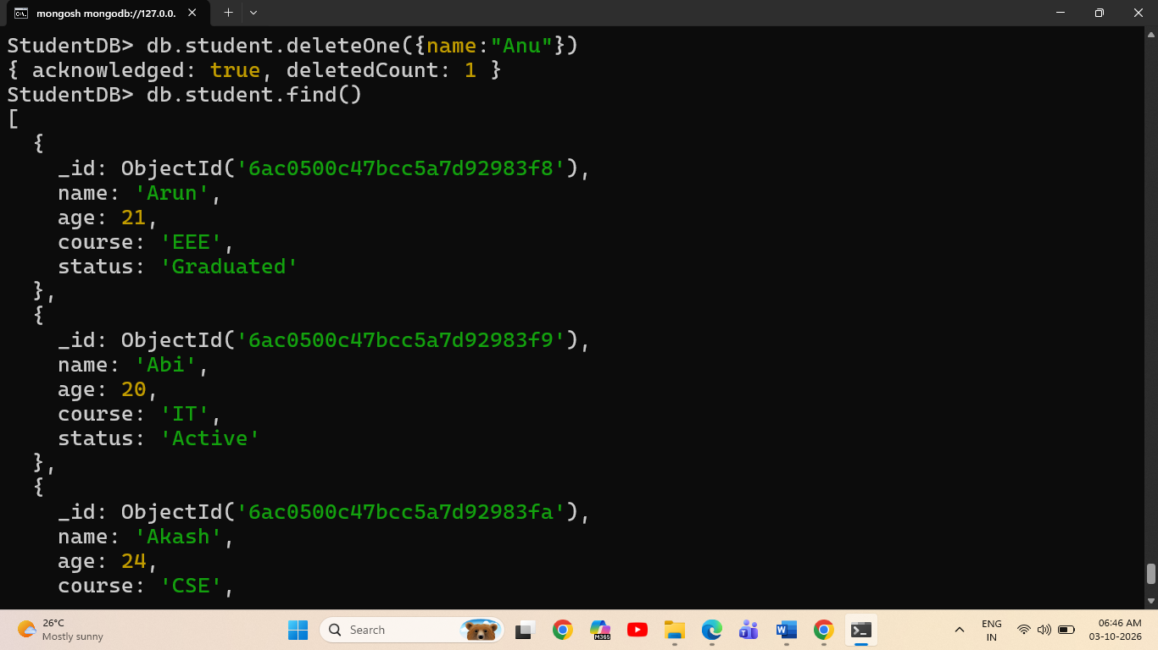
Delete All Documents
Command : db.student.deleteMany({})
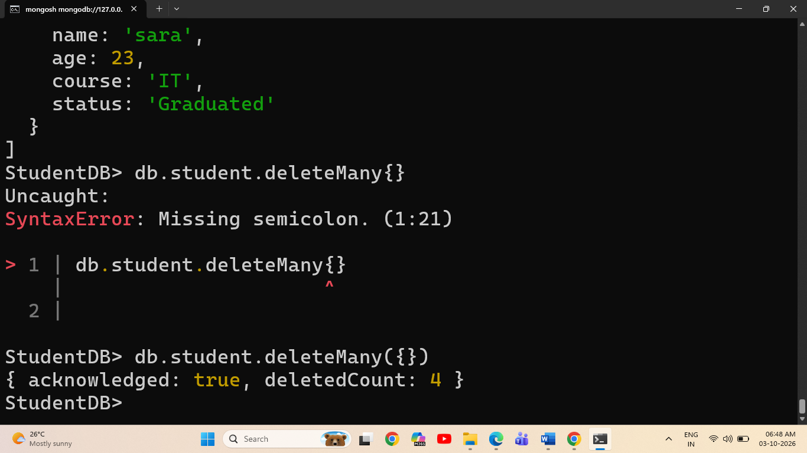
2 Library System
- Database Setup and Insert Operations

Database command
use LibraryDB

Insert one command
db.library.insertOne({title:"Harry Potter",author:"J.K.Rowling",category:"Fantasy",price:500,status:"Available"})

Insert many command
db.library.insertMany([
{title:"The Jungle Book",author:"Rudyard Kipling",category:"Adventure",price:300,status:"Reserved"},
{title:"Cinderella",author:"Charles Perrault",category:"Fairy Tales",price:400,status:"Not Available"},
{title:"Panchatantra",author:"Vishnu sharma",category:"story",price:250,status:"Available"},
{title:"Rich dad and Poor dad",author:"Robert Kiyoski",category:"Finance",price:200,status:"Reserved"}
])

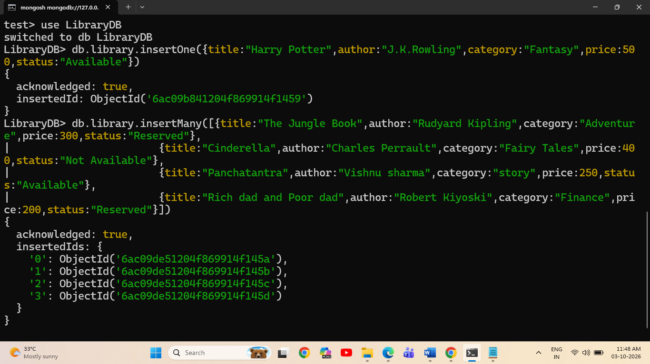

2.Read All Library Documents
Command
db.library.find()
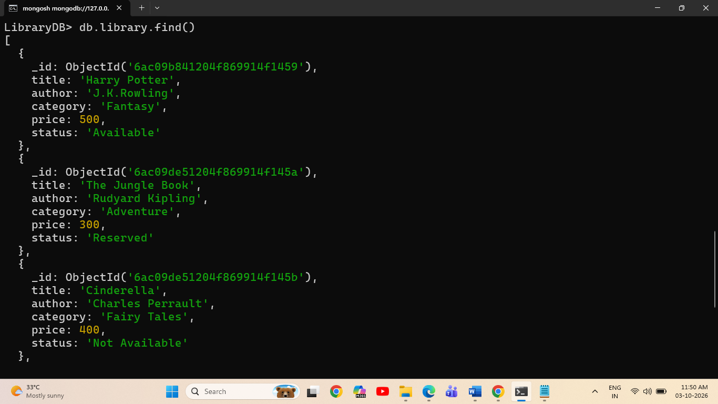
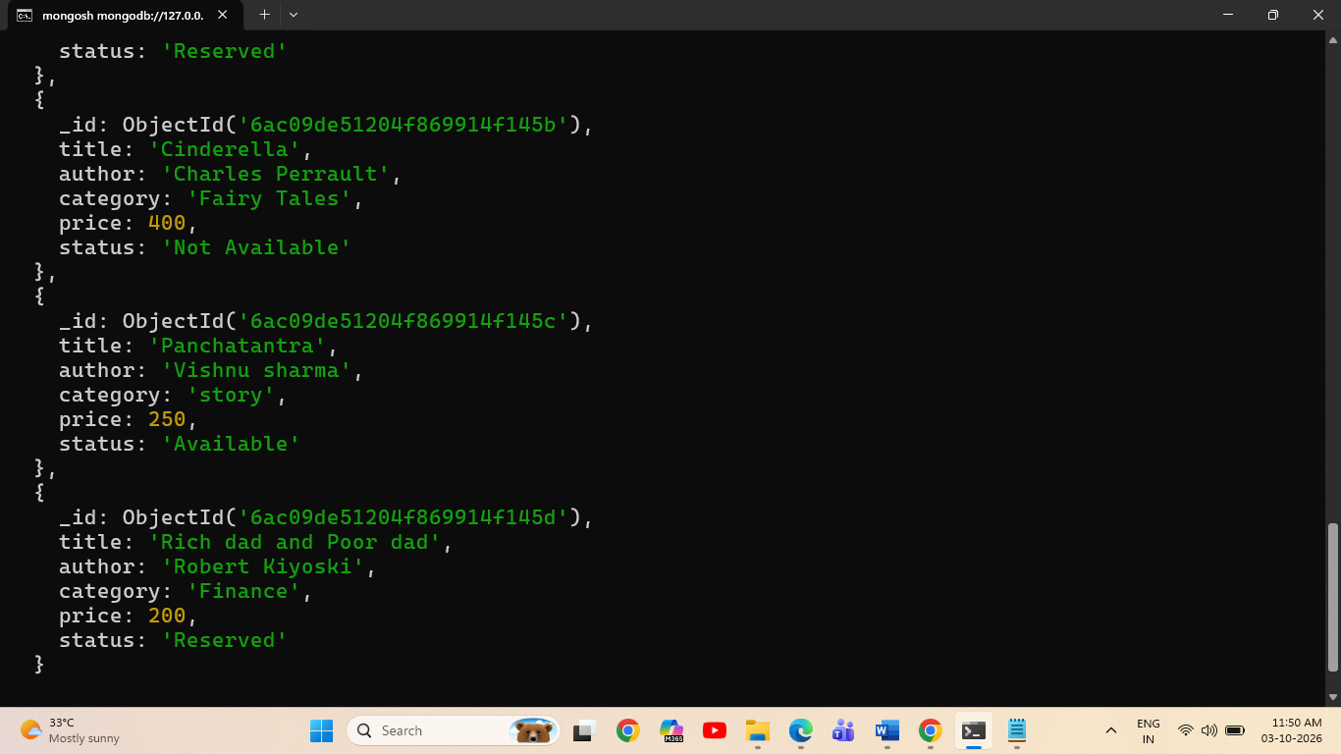

3. Update Operations
Update One Document
Command
db.library.updateOne({status:"Not Available"},{$set:{status:"Available"}})
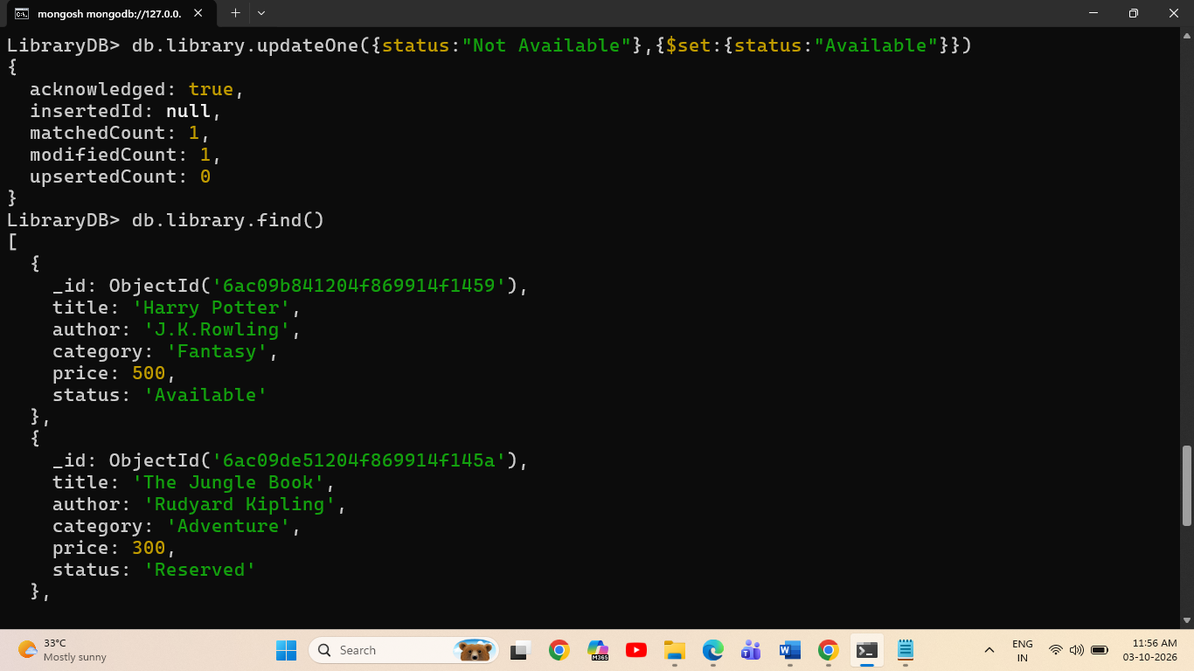

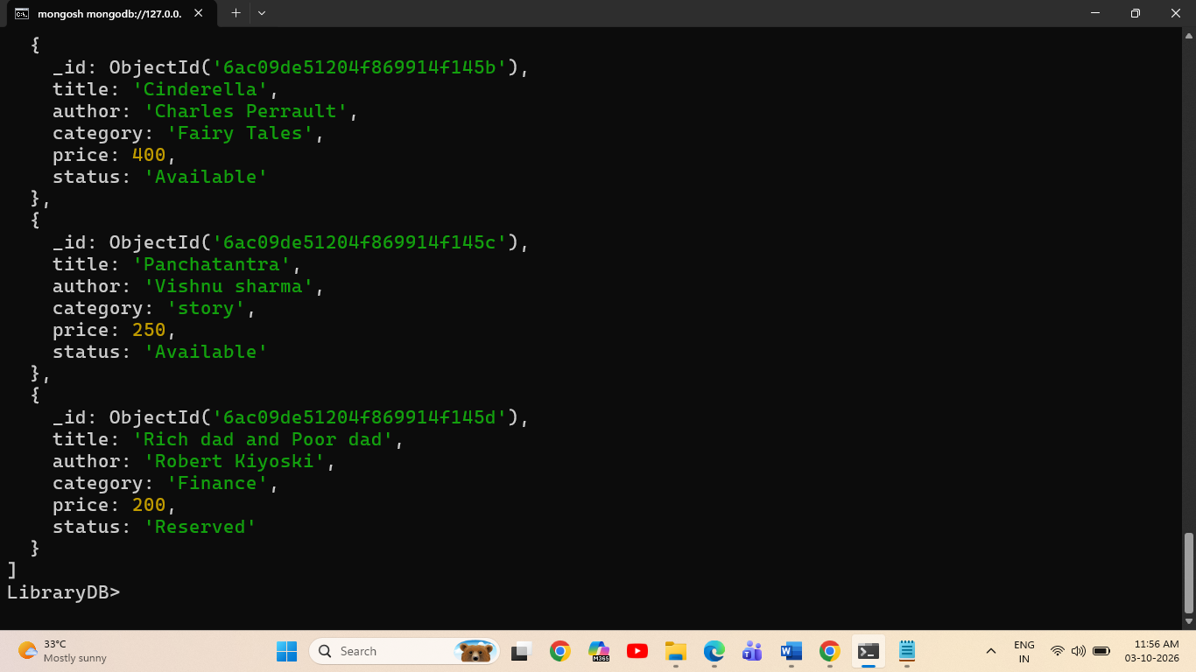

4.Update Multiple Documents
Command
db.library.updateMany({status:"Available"},{$set:{status:"Reserved"}})

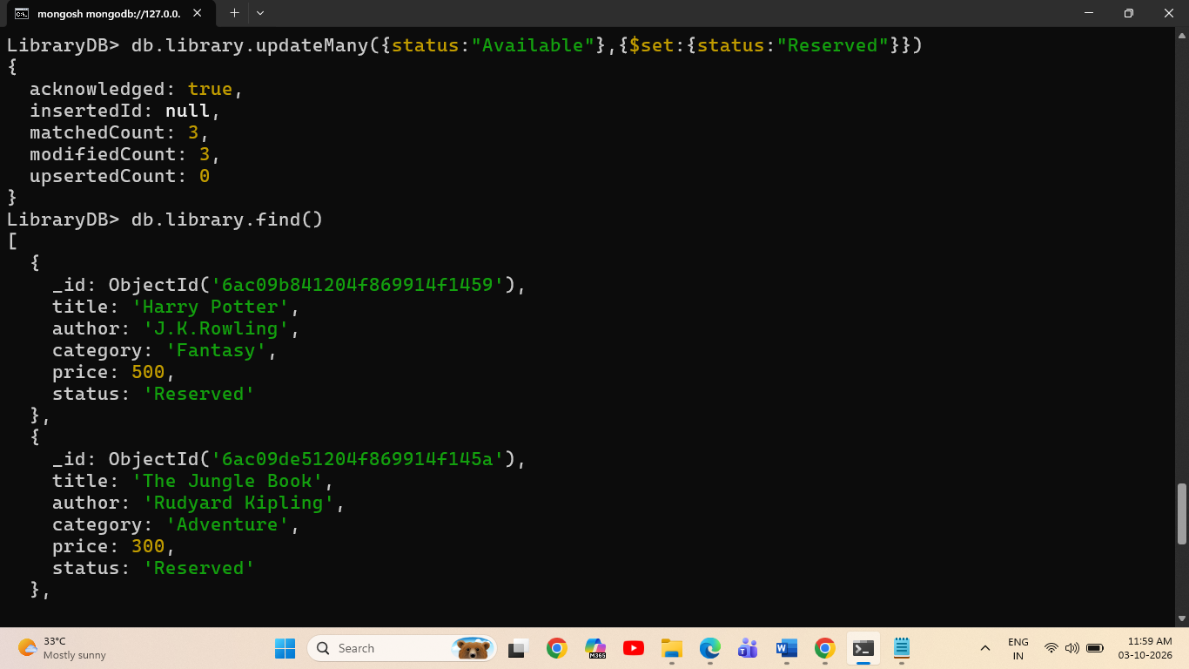

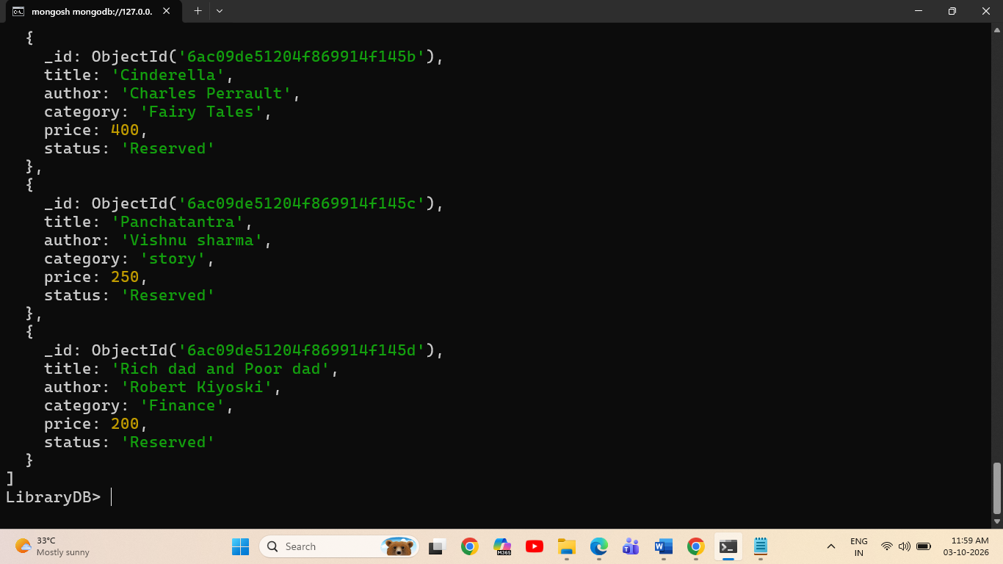

5. Search Operations
1.Search by Status
Command
db.library.find({status:"Reserved"})

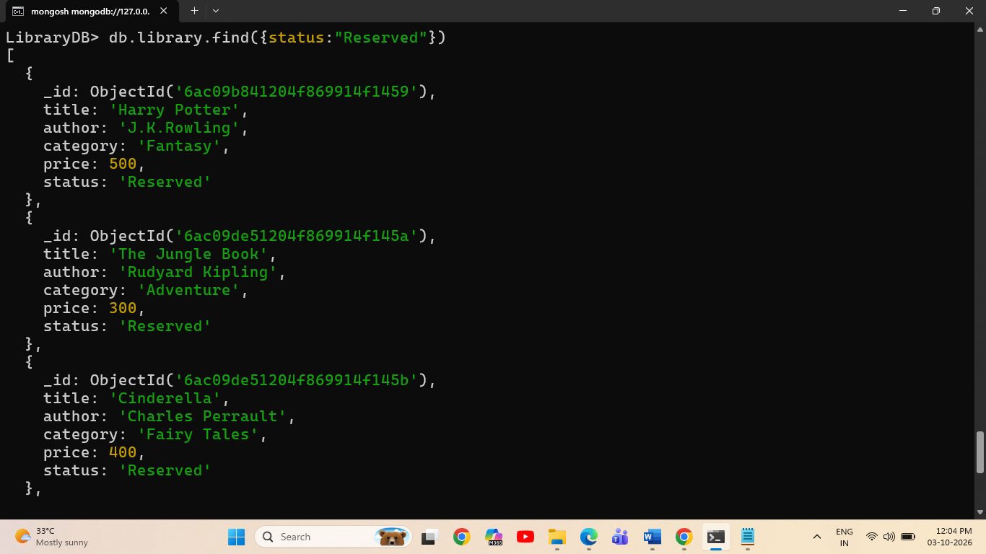

2.Search by Price and Category
Search by price
db.library.find({price:200})
Search by category
db.library.find({category:"story"})

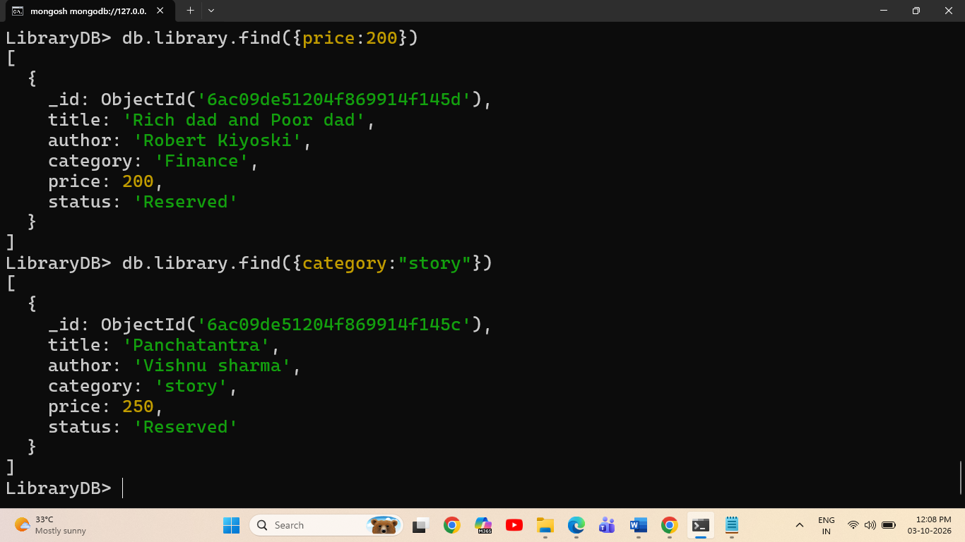

3.Fetch Selected Fields
Command
db.library.find({status:"Reserved"},{title:1,author:1,status:1})

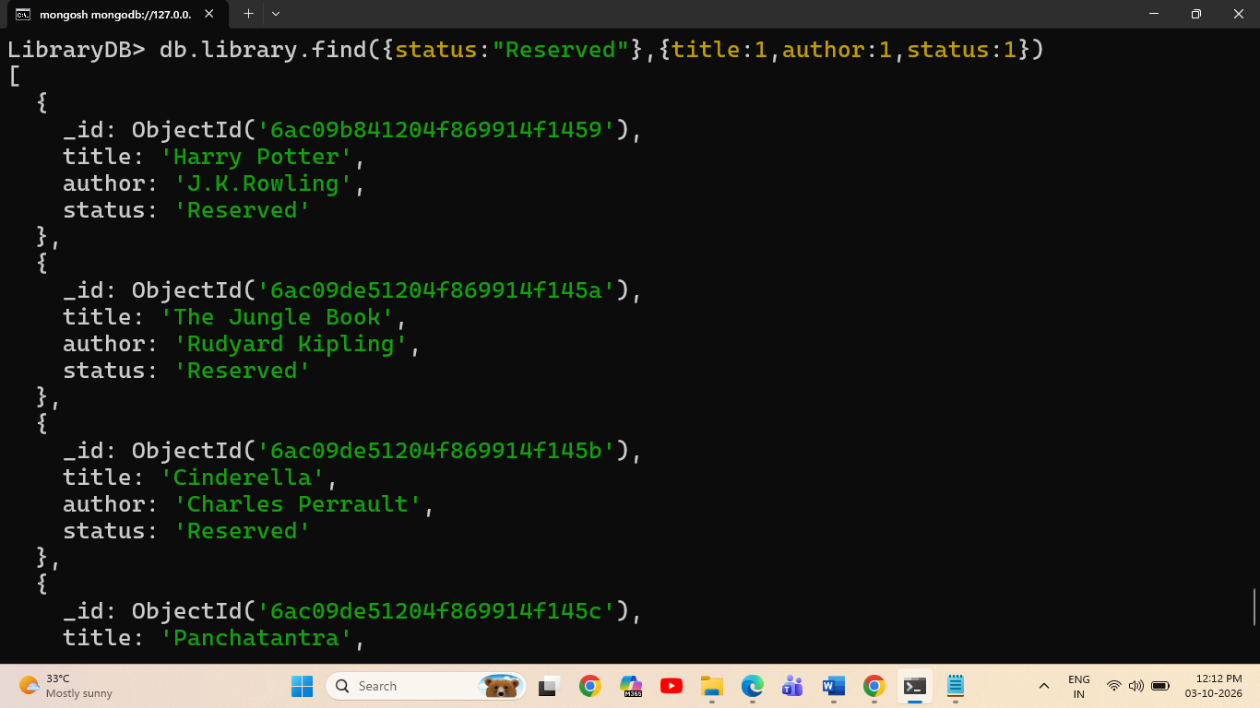

4.Fetch All Fields Except Category
Command
db.library.find({},{category:0})

